ॐ

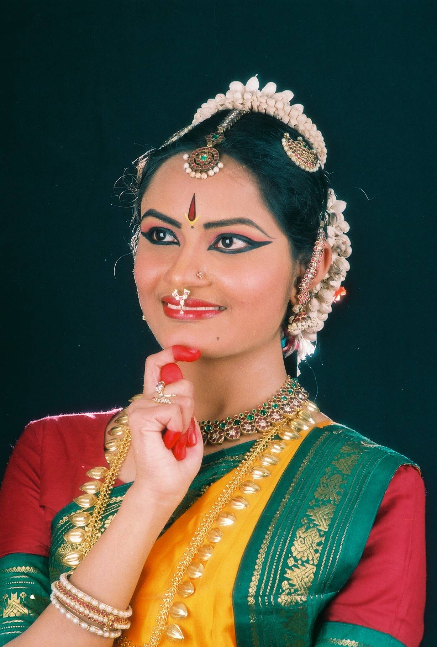
Bharatha Darshana, school of dance and music , serves the sacred art of Bharathanatyam by imparting this knowledge in its pristine purity – the world famous Kalakshetra Style, since past 30 years. It currently operates in Bangalore, with Smt Nagamani Srinivasa Rao (Mani Akka) as its Director. Smt Nagamani has worked with and continues to work with her brother and legendary Bharathanatyam Guru Padmashri Adyar K Lakshman, one of the few persons to have had the gift of learning directly from Smt Rukmini Devi Arundale of Kalakshetra. Smt Nagamani has toured the US, Canada and the carribean several times for performances, arangetrams and workshops. Soujanya Madhusudan, daughter-in-law of Smt Nagamani, and the institute’s Associate Director , now establishes its footprint in the USA. She established the branch of Bharata Darshana in Exton,PA and now functions in Houston, TX.

Soujanya is a gifted and devoted artiste who’s been learning Bharathanatyam since a very young age of 3 from Guru Smt Sumana Nagesh (Director, Natyashree) of Bangalore, in Kalakshetra style.
- She passed the Vidwath exams in Bharathanatyam with distinction.
- She performed her Rangapravesham in the year 1999. Soujanya is an experienced teacher, has been an avid student and a performing artiste of Bharatanatyam for more than 20 years.
- She is proficient in more than 4 Margams.
- She has many performances to her credit which have won good appreciation from critics and art lovers. Several senior Bharathanatyam critics have written appreciative reports in the media about her.
- She is a graded artiste of Doordarshan.

- She was the recipient of the Center for Cultural Resources & Training Talent (CCRT) scholarship for eight consecutive years. She was also the recipient of the Karnataka Sangeetha Nritya Academy for two consecutive years.
- She was one among nominees for the prestigious ‘Singaramani’ Award by the Sur Singar Samsad of Mumbai under the prestigious “Kal-Ke-Kalakar” Sammelan , which is devoted to recognizing promising artistes of the future.
- She has performed for many corporate organizations and foreign delegates in her country.
- She is also an active jury member in the Karnataka Government’s examinations conducted for fine arts and special education, which awards junior, senior & proficiency degrees to more than 100 aspiring art students each year.
- She is a talented choreographer and has worked for several productions of Doordharshan, ETV Kannada and other channels for Indian Television .
- She is one of those few artiste-teachers who is a specialist in imparting Theoretical knowledge as part of her workshops and classes.
- Apart from being a student of Bharathanatyam, she has also dedicated herself to imparting this knowledge to aspiring youngsters and art lovers alike. Her special interest in teaching young children drew her to choreograph “Sambhavami yuge yuge”, a 2 hour thematic dance presentation that included more than 400 children between Grades 1 to 5 from PSBB School in Bangalore, which was a successful attempt to relate Dashavatara of Hindu Mythology and Darwin’s theory of evolution.
- Soujanya is also trained in Carnatic music from Vidwan Bengalooru Gopal Rao, Vidushi Smt Bharathi Venugopal and Vidwan Shri H Ramachandra Rao of Bangalore. She has also learnt Yoga from Shri Venkat Subbiah and Rashtrothana Parishad of Bangalore.
- She includes Theory of Bharatanatyam, Carnatic Music and Yoga as integral parts of the Bharathanatyam classes she conducts for her students.
- Her other projects include:
  - Devi Navarasa Abhinaya – a presentation of the Nava Rasas with Devi as the medium, based on Soundarya lahari and many other kritis.
  - Hasthaprayoga – a meaningful presentation of the basic Hasthas and their applications with the help of Swaras & Adavus.
- She is a member of Association of Bharathanatyam Artistes of India -ABHAI and she has attended many workshops including a special workshop on Karanas by Dr Padma Subramaniam.

- She is blessed to get trained under great Gurus such as Padmashri Adyar K Lakshman, Prof. Balagopal of Kalakshetra, Prof. M R Krishnamoorthy (retd prof , Kalakshetra), Smt Nagamani Srinivasa Rao(sister of Guru Adyar Lakshman) .
- She has performed in lead roles in ballets choreographed by her gurus which include Jwalamalini (Ballet on Jain Goddess), Vachana Vaibhava (based on Vachana Sahitya from Kannada Literature), Chakreshwari, Bharatha Bahubali (based on life & enlightenment of Mahavira), Mahavira (Life of Bahubali after attaining Enlightenment), Ramayana in Kannada, Mohini bhasmasura, Devi Tubhyam Namaha, Akkamahadevi(Based on the life of saint poetess Akkamahadevi) , Krishnanjali, Yashodara Charitre (story of prince siddartha’s wife after he attained enlightenment as Gautama Buddha) to name a few.
- Krishnanjali, Shakti, Devi Navarasa Abhinaya, Sambhavami Yuge yuge, Hasta Prayoga are productions of Bharatadarshana.
- Her performances in Raja Ganapathi temple at Swedesboro, NJ in September 2008, Lakshmi Narayan temple, Delaware in October 2008, Radha Krishna Temple, ISKCON, Philadelphia in October 2008, Drexel University, Philadelphia in October 2008, Hoysala Kannada Sangha of Pennsylvania, New Jersey & Delaware in December 2008, Winter Festival hosted by Shruthilayam Academy at Bharatiya temple, PA in December 20008 were well received and appreciated.
- She had the privilege of training her students in a very short period to perform a beautiful dance drama ‘Sambhavami Yuge Yuge’ based on Sri Jayadevakavi’s Astapadi during the Pranapratishtapana of Bharatiya Temple, PA and the same was highly appreciated by one and all.
- She has trained her students for numerous performances which include the special performance as cultural ambassadors for the students of Bucks county charter school, PA and YMCA, Lionville, PA.
- She continues to teach her students in PA, online through the internet which has been a great success.
- The prestigious Dushera2010 performance in NJ and the Deepavali 2010 performance at YMCA, PA were highly appreciated and is an achievement of online training.
- Her performance for the Deepotsav’10 organised by ISAR, Rice University, Houston was well received and highly appreciated by the Counsel General for its richness in tradition.

Soujanya aims to obtain a Masters degree in Fine Arts and also later focus on doing a PhD specializing in Abhinaya. Her dream is to establish Bharatha Darshana as an institute of fine arts that focuses on imparting Bharathanatyam and other classical art forms in its truest sense and in spreading this knowledge thus inculcating in the younger generation the true spirit of our culture and heritage.

Contact :
Soujanya Madhusudan,
1415, Eldridge Parkway, Apt 2714
Houston, TX 77077
Home Phone – 281 809 8038
Mobile – 832 390 9757
e-mail – soujanyamadhu@gmail.com

